Hello Danielle!

Here is my report on Electronidex!

# Summary

* Would not recommend acquiring Electronidex for anything other than getting more coverage.
* There is a slight opportunity with how they have a good variety of the monitors sold with computer
* Most of Electronidex's sales are transactions with less than 3 items and main stream brand products
* Do not show a good

# Breakdown: Overall Sales

The graph above on the left details the # of items per transaction. Most of the transactions are small, containing less than 5 items. It is a reasonable conclusion that most of their business is with consumers in need of common electronics. This is further supported by their item frequency, which is shown on the right. Here, it is shows that the majority of the products sold are major brand computers. With a deeper dive into the data, it becomes clear most of the purchases are just of a single computer, such as the iMac or HP Laptop, with few or no accessories.

# Market Basket Analysis

In this analysis, the data was looked at in several subsets: all transactions, desktop transactions, monitor transactions.

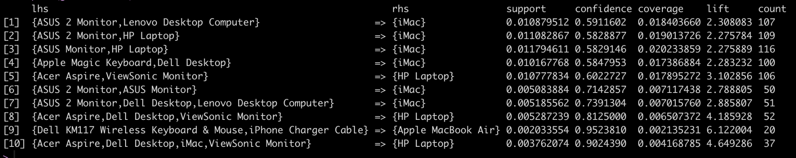

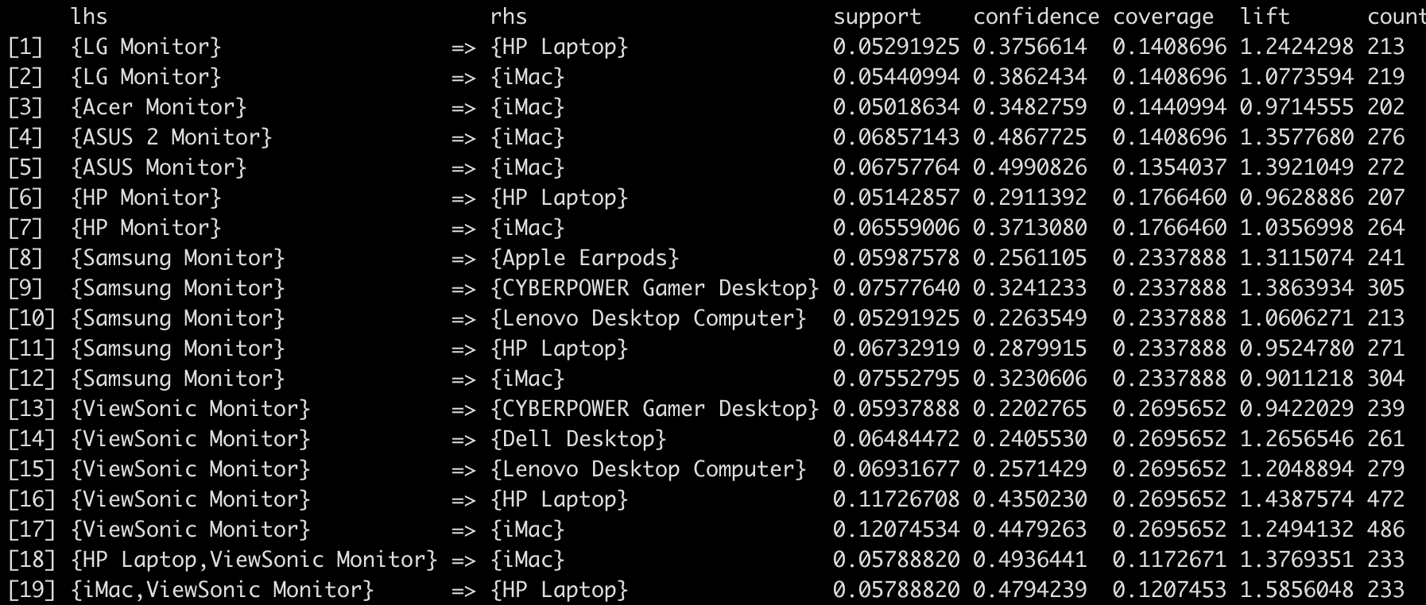

The above rules were generated from these data sets. It is notable the assertion that most of their transactions have a major brand desktop or laptop is still supported here. In these rule sets, the support in each association is low showing that Electronidex's customers don't have a strong preference for what type of add-on they buy except for monitors. There is a relatively significant preference for the ViewSonic Monitor to pair with the main computer that is being bought. This could be caused by marketing or the ViewSonic Monitor being a starter monitor for consumers.

In conclusion, there is no niche or noticeable trend they fill that isn't already provided by Blackwell or any other big electronics retailer. Electronidex does have interesting numbers in their monitor sales, but that seems a bit negligible when analyzing the overall sales. Thus, there is no recommendation to acquire Electronidex for any other purpose than increasing coverage of delivery for products Blackwell already provides.